**Ethereal – MYTH**

**MYTH description**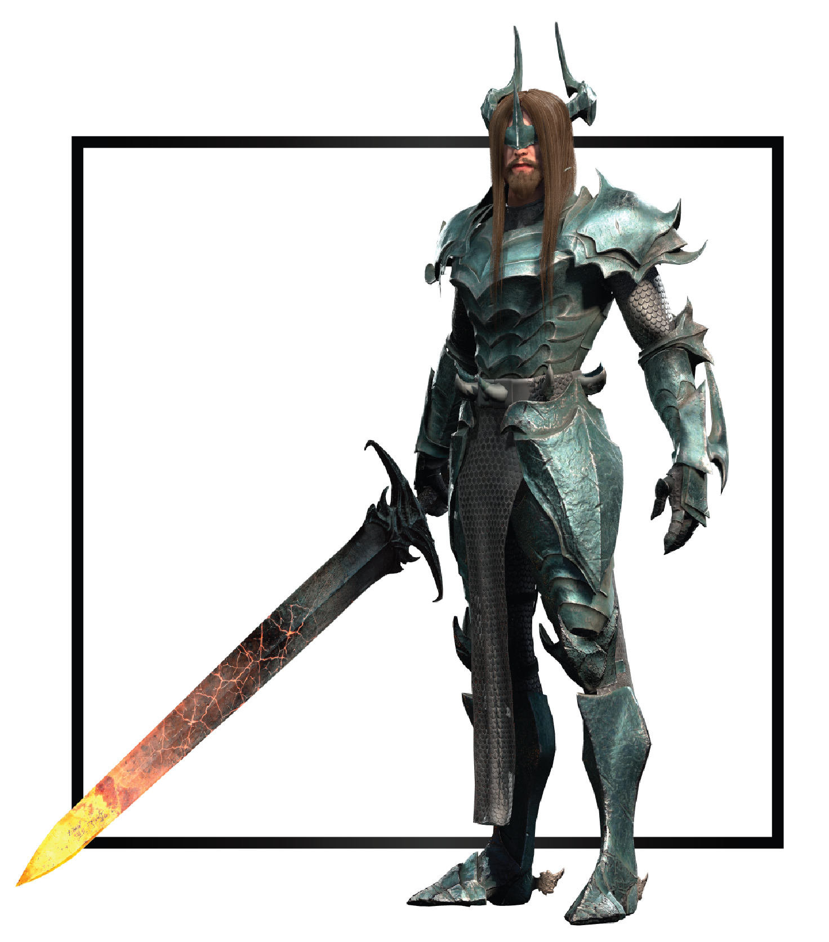

|  |  |
| --- | --- |
| **Name** | Acheron |
| **Title** | First Knight of Kraxus |
| **Realm** | Kraxus |
| **Region** | The Anima Fields |
| **Class** | Knight |
| **Type** | Melee Physical |
| **Release Date** | Coming Soon |

Acheron was the first Guardian to fall under the influence of Azrail, induced by the shadow that Zero’s light created. He sealed his treason when he stole the Xipho sword from The Guardians’ enclave and ran away to Kraxus. To pledge himself to Arawn, Acheron was tasked to go into the Primordial realm and reap the first Anima to corrupt for Azrail’s army.

Pleased with his powerful new recruit, Arawn named Acheron the First Knight and his right hand. After the Fissuring, Acheron bled his once holy body throughout the lands of Kraxus and created the first portals into the emergent realms, ready to return to the fight with a fresh cohort of newly-corrupted Anima.